International Women’s Day
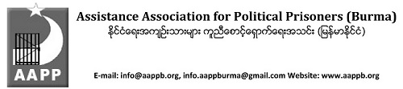
Date . March 8, 2017
International Women’s Day
Today, on International Women’s Day, we at the Assistance Association for Political Prisoners (AAPP) remember and honor all the brave women who sacrificed their freedom to fight for democracy, equality, and human rights in Burma. Many have risen to greatness in face of unimaginable adversity, and are fantastic examples of the strength and power inherent in the female, political prisoner or not. Democracy can only be truly achieved when equality is reached, when men and women alike hold the same rights.
Below, AAPP have identified eight high profile cases which we would like to highlight today to demonstrate the courage and determination of female political prisoners. While we are only showcasing eight, the total number of female political prisoners is far greater, each adding momentum to the movement, empowering women in Burma and worldwide, and proving that women are equal to, and as powerful as men. We would like to thank each and every one of you for your resolve, valor and sacrifices for democracy, we could not continue our work without you.
In Solidarity,
Ko Tate Naing Secretary AAPP
Ko Bo Kyi Joint-Secretary AAPP

